E-Buddy For Rescued Child Labour

Name:- Avanish rai Branch:- *B.E CSE AIML*

CHANDIGARH UNIVERSITY

Name:- Chirag Karnwal

*B.E CSE AIML CHANDIGARH UNIVERSITY*

***Abstract*—This paper focuses on various concepts and studies associated with child labour, their socio-economic issues, the World and Indian scenario of child labour. It analyses the driving factors responsible for child labour in India and World. The various forms of child labour and health hazards they are faced. Various causes of child labour like the curse of poverty, lack of educational resources, Social and economic backwardness, Addiction, disease or disability, The lure of cheap labour, Family tradition, Discrimination between boys and girls. Consequences of Child Labour such as General child injuries and abuses like cuts, burns, and lacerations, fractures, tiredness and dizziness, excessive fears and nightmares. Sexual abuse, particularly sexual exploitation of girls by adults, rape, prostitution, early and unwanted pregnancy, abortion, Sexually Transmitted Diseases (STDs) and HIV/AIDS, drugs and alcoholism. Physical abuse involves corporal punishment, emotional maltreatment such as blaming, belittling, verbal attacks, and bad remarks. Emotional neglect such as deprivation of family love and affection, resulting in loneliness, and hopelessness. Physical neglect like lack of adequate provision of food, clothing, shelter and medical treatment. Lack of schooling results in missing educational qualifications and higher skills thus perpetuating their life in poverty. We suggest for a new approach that puts people and the work they do at the center of economic and social policy and business practice: a human-centered agenda for the future of work.Introduction.**

**Keywords: poverty, Illiteracy, health hazardous, sexual abuses.**

* 1. Introduction Definitions of Child Labour: (i). Children who are engaged in work unsuitable for their capacities as children or in work that may jeopardize their health, education or moral development and whose age is below 14 years. Children who practice and engage in economic activities, on a part or full-time basis. (ii). The practice deprives children of their childhood and is harmful to their physical and mental development and (iii). Child labourers constitute a group of working children who are either too young to work or are engaged in hazardous activities- that is, work that is potentially harmful to their physical, social, psychological or educational development, UNICEF (2013). 2. Review of Literature The prevalence of child labour is one of the most important problems confronting the world at large, especially developing countries such as India. Millions of children are engaged in hazardous situations, or

conditions, such as working in mines, working with chemicals and pesticides in agriculture or working with dangerous machinery, Lal (2016). Child Labour is a global phenomenon. It exists both in the developing and the developed countries though with a difference in cause and magnitude. Its prevalence is more in the developing countries as compared to the developed ones, because the families, to which the working children belong, are in an urgent need of income of child labour for their subsistence, whereas children in the developed countries are often working for pocket money, Lal (2006). There are indications of high numbers of worst forms of child labour among indigenous peoples in certain countries in South Asia, Southeast Asia, and Latin America. Indigenous and tribal children are found to make up a large part of child labourers in certain risk areas, such as debtbondage in South Asia, migratory agricultural wage labour in Central America and Mexico, and trafficking in Southeast Asia. In Latin America, it is estimated that indigenous children are twice as likely to work as their peers, B. Suresh Lal, (2019a).

* Among a myriad of factors contributing to child labor, joblessness, financial hardship, and household indebtedness stand out as paramount. Numerous parents obtain financial assistance from landlords or employers, reimbursing these loans through their children's labor. In certain instances, youngsters find themselves compelled to temporarily relocate to nearby cities or urban areas in neighboring states to secure essential sustenance (Lal, 2006). The economic challenges within a family: Women and young girls often face unequal access to shared resources in times of familial financial struggle. The female members, particularly young girls, bear the brunt of the family's economic adversity.
* A poor family naturally jeopardizes female children. Every chance is used for avoiding the burden of a female. So poor families naturally resort to child marriage to avoid all sorts of the burden of a female child. Sometimes it can also be perceived that poor families selling girls and child marriage are a hidden form of selling the girl. Marring child to gods as a tradition is also originates from family poverty, Lal (2015). Family poverty, ignorance of the parents, lack of support by parents, community passivity and children's passivity towards education are the key factors responsible for child

XXX-X-XXXX-XXXX-X/XX/$XX.00 ©20XX IEEE

labouring in the village. The discriminating attitude of parents towards the education of the girl child is adding the number of child labourers in the village. People prefer to keep their girl children away from education as compared to male children. So most of the child labourers in case of never admitted are of female children. Both the never admitted and drop-out children, in turn, get trapped into the child labouring, Naseer(2013). The working children themselves may not be productive but are capable of relieving the adults for productive employment by engaging themselves in domestic chores and looking after younger children in the home.

# 3. Objectives and Methods

Global estimates reveal that 152 million children, comprising 64 million girls and 88 million boys, are engaged in child labor globally, constituting nearly one in ten of all children worldwide. Notably, 71 percent of children in child labor are involved in the agricultural sector, while 69 percent perform unpaid work within their own family units.

Alarmingly, approximately 73 million children, almost half of those in child labor, are exposed to hazardous work that directly jeopardizes their health, safety, and moral development.

Expanding the scope to encompass both child labor and the employment of children above the legal working age, there are a total of 218 million children in employment. Furthermore, forced labor, considered the most severe form of child labor and assessed using a distinct methodology, affects 4.3 million children (ILO, 2017).

In accordance with the Global Childhood Report 2019, significant positive impacts are observed, including 4.4 million fewer child deaths annually, 49 million fewer stunted children, 115 million fewer children out of school, 94 million fewer child laborers, 11 million fewer married girls, 3 million fewer teen births each year, and 12,000 fewer child homicides per year.

The research broadly explores an economic perspective on child labor in India, with the following objectives:

Investigate the Socio-economic Background of Child Labor in India

Identify Factors Responsible for Child Labor in India and Worldwide

Examine Forms of Child Labor and Associated Health Hazards

Study the Consequences of Child Labor

The study relies on secondary data, encompassing various reports and documents from organizations such as the World Bank, International Labour Organization (ILO), Save the Children, and UNICEF. Additionally, it incorporates findings from various research studies conducted by scholars both in India and internationally.

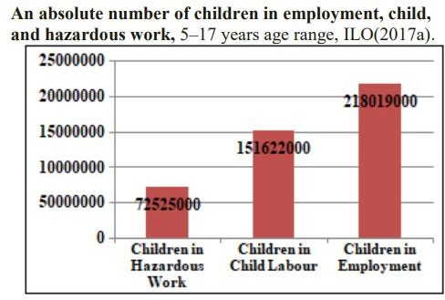

# Who are the Children at Risk in the World?

**Risk-1**: One billion children live in countries plagued by poverty. Children living in poverty face a higher risk of death before age 5, malnutrition that stunts their growth, being out of school, being forced into child labour or early marriage, and giving birth while they are still children themselves.

**Risk-2**: At least 240 million children live in countries affected by conflict and fragility. 3 these children are at heightened risk of death before age 5, stunted growth due to malnutrition, being out of school, being forced to work, and being forced from their homes under dangerous and frightening circumstances.

**Risk-3**: 575 million girls live in countries characterized by discrimination against girls,4 often placing them at heightened risk of death before age 5, being denied education, being forced into early marriage, and/or giving birth before they are emotionally and physically ready.

Because of who they are and where they live, these children risk being robbed of their childhoods and future potential. This assault on childhood also deprives nations of energy and talent they need to progress, Save the Children (2018).

# Results and Discussion

We gave elaborative analysis on different aspects of child labour in present day scenario as well as future requirement to eliminate child labour from the world.

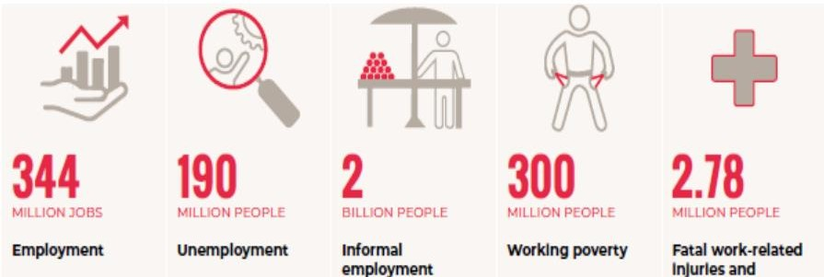

The above figure reveals the global scenario of future works that, Employment: 344 million jobs need to be created by 2030, in addition to the 190 million jobs needed to address unemployment today, Unemployment: 190 million people are unemployed, of whom 64.8 million are youth. Informal employment: 2 billion people make their living in the informal economy. Working poverty: 300 million workers

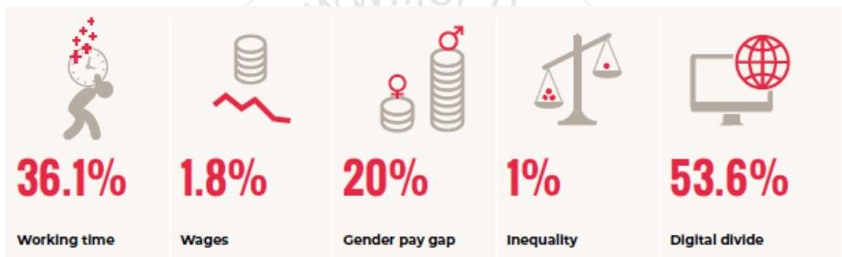

1. *Working hours: A staggering 36.1% of the global labor force engages in prolonged working periods (surpassing 48 hours weekly). Compensation: The expansion of wages witnessed a descent, dropping from 2.4% to 1.8% amid 2016 and 2017. Gender salary disparity: Women experience remuneration approximately 20% lower than their male counterparts. Disparities: From 1980 to 2016, the wealthiest 1% of the global populace garnered 27% of the total increase in global income, while the least affluent 50% received a mere 12%. Technology gap: Merely 53.6% of households worldwide possess internet connectivity. In burgeoning nations,*
2. *the share is only 15%, Messenger (2018), ILO(2018d), Alvarado (2018), ITU (2017).*

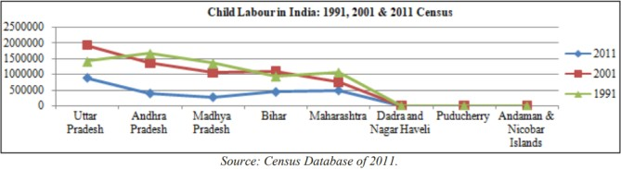

live in extreme poverty

The scenario of child labour in India varies from state to state. In states like Uttar Pradesh, Andhra Pradesh, Madhya Pradesh, Bihar, Maharashtra, Dadra and Nagar Haveli, Puducherry and Andaman & Nicobar, the issue of child labour is an important point of debate for the social watchers as it has assumed unbearable proportions. But the silver lining is that in these states also the phenomenon of child labour is reducing gradually from 1991 to 2001 and 2011. Below we give the details of states with the highest and lowest number of child labour and the ratio of child labour to the total population in these states.

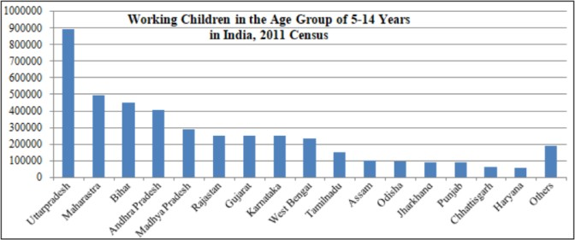

The working children in the age group of 5-14 years in India. In Indian state like Uttar Pradesh, Maharashtra, Bihar, Andhra Pradesh, Madhya Pradesh, Rajasthan, Gujarat, Karnataka, West Bengal, Tamil Nadu, Assam, Odisha,

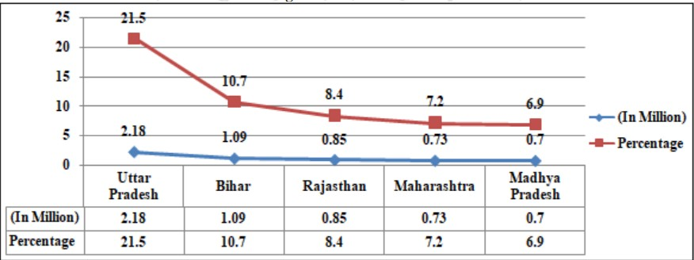

Incidence of child labour in India and the top five states, such as Uttar Pradesh, Bihar, Rajasthan, Maharashtra, and Madhya Pradesh constitute nearly 55% of total working children in India.

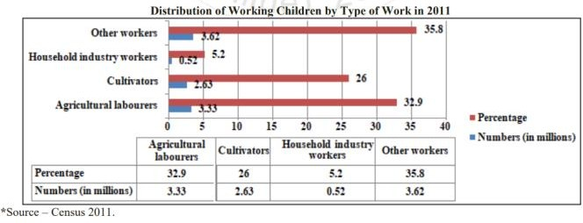

Note: ‘Other workers’: Workers other than cultivators, agricultural labourers or workers in household industries. Child labour has been distributed as per their working type, the highest percentage has been recorded in agriculture followed by cultivator and household workers. It shows that agriculture is engaging more child labour than any other sectors in India. The reason is the agriculture sector doesn't require any skills to work in.

# Forms of Child Labour

The worst forms of child labour are slavery and similar issues such as the trafficking of children, debt bondage, serfdom, children in armed conflict. Slavery is where one person is owned by and made to work for another person without having any say over what happened to them. In factories like carpet-making, lock-making, brassware, export-oriented

garment units, gem polishing export industry, leather units and, diamond industry, etc.

* In Shops and small scale vendors
* In Household
* In farms
* In mines (Labour)
* Near furnaces, welding, hazardous materials
* Children engaged in illegal activities smuggling, prostitution, child pornography, etc.
* In countries including some parts of India, Pakistan, Bangladesh, Afghanistan children are engaged in terrorist activities.
* Begging (more common in India) ILO (2017).

# Causes of Child Labour

The curse of poverty: The main reason for child labour in India is poverty. Most of the country's population suffers from poverty. Due to poverty, parents cannot afford the studies of their children and make them earn their wages from a tender age. In fact, they are well aware of the grief of losing their loved ones to poverty many times. They send their small children to work in factories, homes, and shops. They are made to work to increase the income of their poor families at the earliest. These decisions are taken only for the purpose of eking out a living for their family. But such decisions shatter children's physical and mental state as they lose their childhood at an early age.

# Lack of educational resources:

Even after 72 years of our country's independence, there are instances where children are deprived of their fundamental right to education. There are thousands of villages in our country where there are no proper facilities for education. And if there is any, it is miles away. Such administrative laxity is also responsible for child labour in India. The worst sufferers are the poor families for whom getting their children educated is a dream. Sometimes the lack of affordable school for the education of poor children leaves them illiterate and helpless. Children are forced to live without studying. And sometimes such compulsions push them into the trap of child labour in India.

# Social and economic backwardness:

Social and economic backwardness is also the main reason for child labour in India. Socially backward parents do not send their children to receive an education. Consequently, their children are trapped in child labour. Due to illiteracy, many times parents are not aware of various information and schemes for child education. Lack of education, illiteracy and consequently the lack of awareness of their rights among them have encouraged child labour. Also, uneducated parents do not know about the impact of child labour on their children. The

conditions of poverty and unemployment give rural families a compulsive basis for engaging children in various tasks. In fact, feudal, zamindari system and its existing remnants continue to perpetuate the problem of child labour in India.

# Addiction, disease or disability:

In many families, due to alcohol addiction, disease or disability, there is no earning, and the child's wages are the sole means of family's sustenance. Population growth is also increasing unemployment, which has an adverse impact on child labour prevention. So, parents, instead of sending their children to school, are willing to send them to work to increase family income.

**The lure of cheap labour:** Motivated by the pursuit of inexpensive workforce, certain retailers, corporations, and industrialists engage minors, ensuring reduced payment and thereby constituting the utilization of economical labor.

* Merchants and modest entrepreneurs involve children in tasks equivalent to those assigned to older individuals but remunerate them with only half the wages. In instances of child labor, the probability of theft, avarice, or financial misconduct is diminished. The evolution of globalization, privatization, and a consumer-driven ethos has intensified the demand for affordable labor, aligning with the economic requirements of impoverished families, thereby fostering the prevalence of child labor in India.
* In the pursuit of maximizing profits through the utilization of cost-effective labor, certain shopkeepers, companies, and factory owners resort to the employment of children, thereby enabling them to reduce overall labor expenses. This practice involves shopkeepers and small-scale business owners assigning tasks to children comparable to those performed by their adult counterparts, yet compensating them with only half the standard wages.
* Notably, in the context of child labor, there is a diminished likelihood of occurrences such as theft, avarice, or financial misappropriation. The evolving trends of globalization, privatization, and the pervasive influence of consumerist culture have significantly heightened the demand for economical labor, establishing a connection with the economic needs of impoverished families and consequently fostering the prevalence of child labour.

1. [1] Alvarado, F.; Chancel, L.; Piketty, T.; Saez, E.; Zucman, G. (editors). (2018); World Inequality Report 2018 (Cambridge, MA, Published by Belknap Press, Harvard University).
2. B. Suresh Lal, (2019): Child Labour in India: an investigation in socioeconomic and health conditions of tribes, Proceedings of The IRES International Conference, Cape Town, South Africa, 24th-25th March 2019, https://[www.researchgate.net/publication/331562507](http://www.researchgate.net/publication/331562507) R. Nicole, “Title of paper with only first word capitalized,” J. Name Stand. Abbrev., in press.
3. B. Suresh Lal, (2019a): Child Labour in India: an investigation in socioeconomic and health conditions of tribes, Proceedings of The IRES

International Conference, Cape Town, South Africa, 24th-25th March 2019, [www.iraj.in](http://www.iraj.in/)

1. B. Suresh Lal, (2015): Socio-Economic and Health Issues of Banjaras in the Era of Globalization: A Study in Telangana Tribal Villages, International Journal of Physical and Social Sciences (IJPSS), Vol-5, Issue-6, June, ISSN: 2249-5894, pp 195-211.
2. Haq, Mahbub-ul, (1997), Human Development in South Asia, Oxford University Press, Karachi. [8] International Labour Office (2017), Ending Child Labour by 2025: A Review of Policies and Programmes, Geneva.